**Learning management system**

**A learning management system (LMS) is a**[**software application**](https://en.wikipedia.org/wiki/Software_application)**for the administration, documentation, tracking, reporting and delivery of**[**educational**](https://en.wikipedia.org/wiki/Educational)**courses or training programs.They help the instructor deliver material to the students and other assignments, track student progress, and manage record-keeping. LMSs are focused on online learning delivery but support a range of uses, acting as a platform for fully**[**online**](https://en.wikipedia.org/wiki/Internet)**courses, as well as several hybrid forms, such as**[**blended learning**](https://en.wikipedia.org/wiki/Blended_learning) **and**[**flipped classrooms**](https://en.wikipedia.org/wiki/Flipped_classroom)**. LMSs can be complemented by learning technologies such as a**[**training management system**](https://en.wikipedia.org/wiki/Training_management_system)**to manage**[**instructor-led training**](https://en.wikipedia.org/wiki/Instructor-led_training)**or a**[**Learning Record Store**](https://en.wikipedia.org/wiki/Learning_Record_Store)**to store and track learning data.**

### **Purpose**

**An LMS delivers and manages instructional content, and typically handles student registration, online course administration, and tracking, and assessment of student work. Some LMSs help identify progress towards learning or training goals. Most LMSs are web-based, to facilitate access. LMSs are often used by regulated industries (e.g. financial services and biopharma) for**[**compliance training**](https://en.wikipedia.org/wiki/Compliance_training)**. Some LMS providers include "performance management systems", which encompass employee**[**appraisals**](https://en.wikipedia.org/wiki/Performance_appraisal)**, competency management, skills-**[**gap analysis**](https://en.wikipedia.org/wiki/Gap_analysis)**, succession planning, and multi-rater assessments (i.e.,**[**360 degree reviews**](https://en.wikipedia.org/wiki/360_degree_review)**). Some systems support**[**competency-based learning**](https://en.wikipedia.org/wiki/Competency-based_learning)**.**

**DIAGRAM TO DEPICT ABOUT LMS**

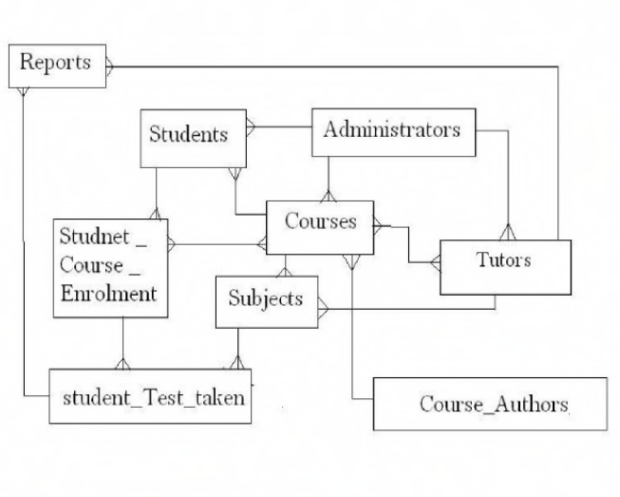

**GIVEN ABOVE IS A SAMPLE FORMAT**

**OF LEARNING MANGEMENT SYSTEM.**

**WHICH INCLUDES THE THE STUDENT DETAILS, ASSIGNMENT AND LOGIN DETAILS CAN BE USED TO MAKE LMS MORE USER AND STUDENT INTERACTIVE.**

**SWOT ANALYSIS**

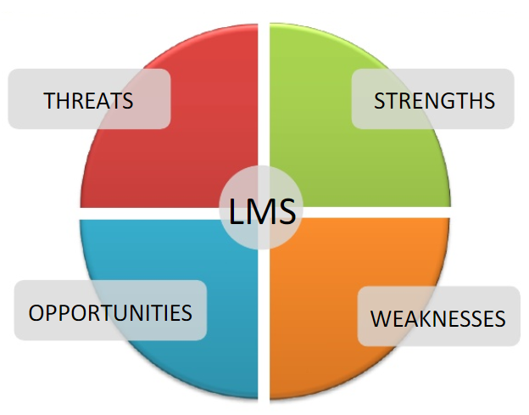

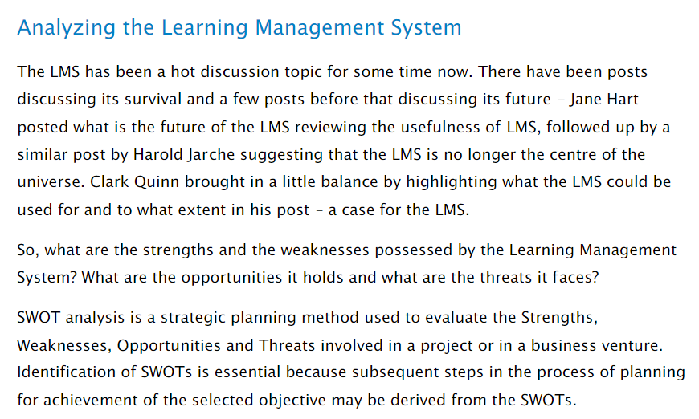

**ANALYSING THE STRENGTH**



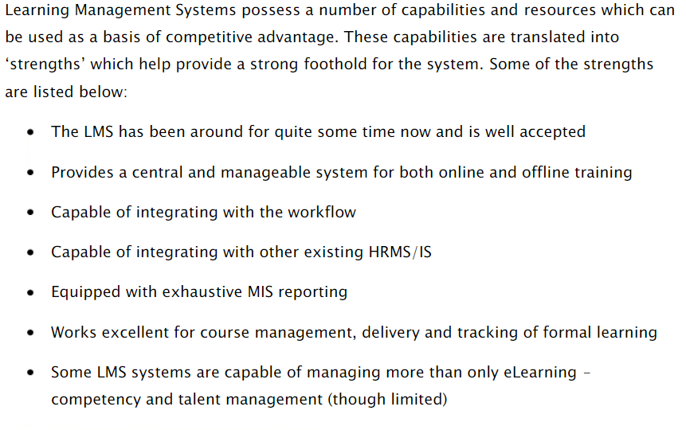

**ANALYSING THE WEAKNESS**

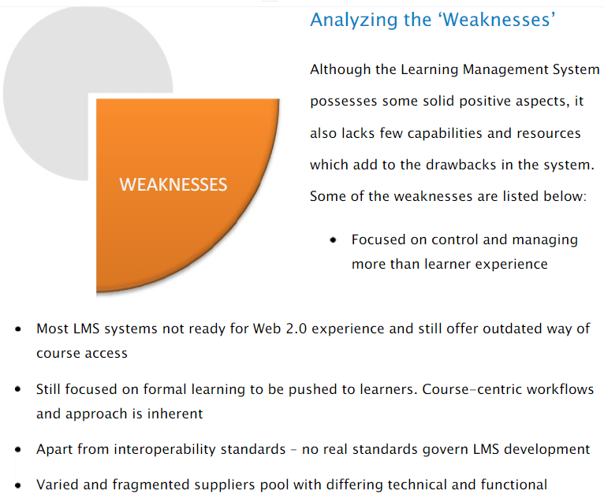

**ANALYSING THE OPPORTUNITIES**

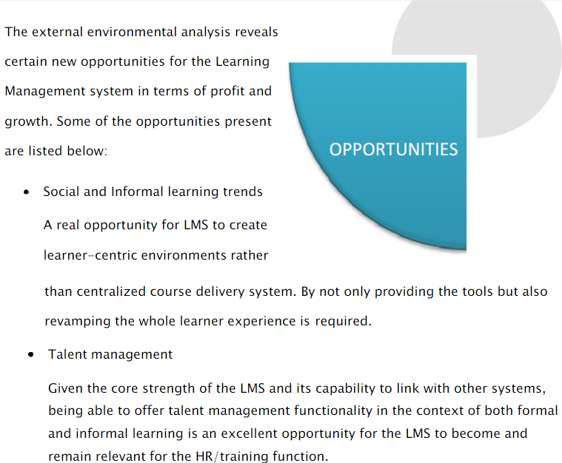

**ANALYSING THE THREATS**

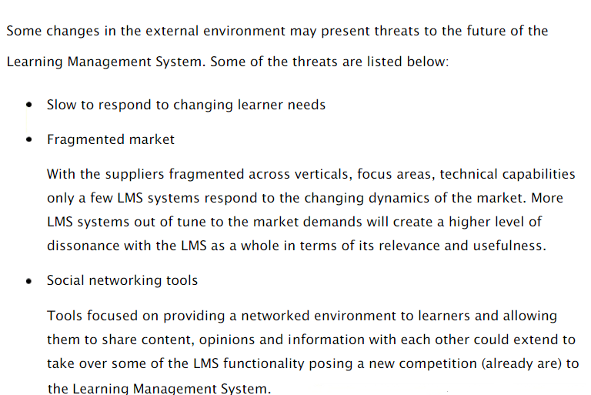

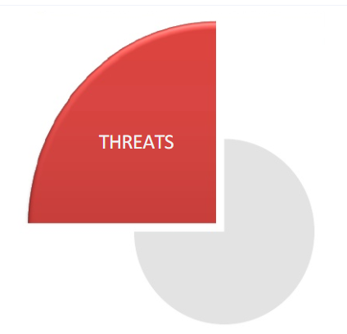

**SCOPE OF THE PROJECT LEARNING MANAGEMET SYSTEM**

**1.Provide the information of student,quiz ,assigments etc.**

**2.manage the information of student.**

**3.show the description and information of the course and faculty.**

**4.It increases the efficiency of managing the course for student.**

**5.It automates the existing manual system by he help of internet.**

**6.To assist the staff in capturing the effort spent on their respective working areas.**

**7.Provide searching facilities & REDUCES PAPERORK.**

**ABSTACT OF THE PROJECT LEARNING MANAGEMENT SYSTEM**

**The purpose of learning management system is to automate existing manual system by the help of internet enabled computerized equipments and full fledged website , wich is easily accessible.**

**So that it could be easily accessed by any one whether student or faculty on anytime anywhere through the Internet Connection.**

**This reduces the most of the paper work as example instead of paper used in time tables ,circulars, announcement;Now through website it could be easily accessed by the students.**

**LEARNING MANAGEMENT SYSTEM IS MORE RELIABLE THAN PAPERWORK MANAGEMENT SYSTEM.**

**How Does an LMS Work?**

**To experience the way an LMS works, let’s take a look at a very basic example of how an LMS can be deployed.**

**A company wants to educate its sales team about a soon-to-be-launched product.**

**To do that, they use the course builder function within their LMS to create slides, bite-sized documentation, quizzes and certifications. Once the course materials are ready, each member of the sales team can log into the LMS with their own personalized account to begin learning (and now you know where the term eLearning came from).**

**When an employee feels ready, he or she can take the quizzes or tests required to achieve their certification — proving that they’re qualified to sell the product at the standard required.**

**The LMS can track the progress of each employee, so administrators can see how well learners are moving through the course material, who has qualified, and who remains confused about the topic.**

**What Are The Benefits of an LMS?**

**The more obvious benefits of an LMS include the development of knowledge amongst students or employees. But let’s dig a little deeper into why an LMS is so useful.**

**First, an LMS gives an organization somewhere to centrally house its training and development content. It can be stored, managed, edited and deleted from within the same software.**

**An LMS also saves money, since traditional forms of training like seminars or training days directly impact the company’s bottom line. With an LMS, learners can access their eLearning environment from anywhere, at any time, at their own pace and without draining additional company resources or incurring travel expenses.**

***Basic Components of an LMS***

**With hundreds of learning management systems on the market, you’ll struggle to find two with identical feature sets. However, here are some fundamental features that no LMS should be without:**

* **eLearning Standard Compliance: The ability to exchange data with other eLearning software through compliance with eLearning standards such as SCORM and Tin-Can.**
* **Multichannel Access: Learners are able to access their account and their course material through desktop, tablet and smartphone devices.**
* **Course Management, Creation or Importing: Administrators are able to either build courses using a built-in course builder, or import course material from other formats.**
* **Document Management: The ability to upload and manage documents containing curricular content.**
* **Course Calendars: Features that support the creation and publication of course schedules, deadlines and tests.**
* **Social Features: Notifications, messaging and discussion forums to promote knowledge sharing and engagement.**
* **Tracking and Reporting: Detailed reports should be available so that both administrators and learners may view average test scores, final test scores, single user reports, company and so forth.**
* **Assessment and Certification: Pre-course assessments (or diagnostic assessments) to assess employee knowledge levels in order to assign suitable content to them. Digital or physical certification should also be supported.**

**Enterprise LMS Features**

**An enterprise learning management system has additional features that make it better suited for delivering training to corporate staff, whether they're in-house employees or external partners. Those enterprise-specific features can include:**

* **Enhanced Security: Many corporate LMS solutions boast single-sign-on, two-factor authentication, firewalls and regular data backups to ensure data security.**
* **Scalability: Enterprise LMSs are often cloud-based, making them far easier and faster to scale compared to on-premise learning management systems.**
* **White Labeling: The company can often brand the LMS so that it appears to be in-house software.**
* **Multi-lingual Support: For global companies who need to deliver course material and user interfaces in the languages native to their employees.**
* **ILT Classrooms: Instructor-led training classrooms enable learners to attend live streamed or recorded content with an instructor, whether individually or in groups.**
* **Personalization: Personalized learning paths or documentation can be delivered to specific learner groups based on their roles, knowledge or experience.**
* **Extensions and Integrations: An enterprise LMS can typically integrate with other eLearning software, communication platforms and CRMs.**
* **Gamification: Learners can earn points, badges or digital rewards for completing courses or taking quizzes. Organization-wide leaderboards based on those points help foster a culture of friendly competition.**
* **eCommerce: Many enterprise learning management systems boast eCommerce features so that companies can sell training sessions to third parties.**
* **APIs: Some enterprise LMSs allow the company to extend the platform's features with custom scripts and plugins based on a publicly available and well-documented API.**

**LCMS vs LMS**

**If you’re confused about the label LCMS (learning content management system), don’t be.**

**An LCMS refers to software that’s intended to help developers and administrators build and manage eLearning content. Unlike an LMS, it doesn’t provide the features needed to actually deliver those courses and track learner progress.**

**The good news is that, in the modern LMS market, almost all learning management systems are also learning content management systems. Many major LMS provide course building features that allow for course creation and management in the way a traditional LCMS would. Or, at the very least, major LMS will be able to import course content from Microsoft Office or other legacy platforms.**

**So, choose a powerful LMS, and you’ll get an LCMS as part of the package.**

**Talent Management System (TMS) vs LMS**

**Finally, let’s clear up the misconception about the difference between a talent management system and a learning management system.**

**TMS a software suite comprised of the "four pillars" of**[**talent management**](https://en.wikipedia.org/wiki/Talent_management)**: recruitment, performance management, learning and compensation management. Thus, a TMS actually houses and LMS within itself, along with three other software applications that encompass employee recruitment, development and retention.**

**GROUP MEMBERS**

***GROUP 11***

**ROLLNO. NAME REGISTRATION NO.**

**41. JATIN CHAUHAN *11702228***

**42. SAGAR SARKAR *11702191***

**43. BOLLI MANISH  *11702205***

**44. SOURAV BHATIA *11702273***